Project Design Phase-II
Data Flow Diagram & User Stories

Date | 20-02-2026
Team ID | LTVIP2026TMIDS66114
Project Name | Smart Sorting
Maximum Marks | 4 Marks

Data Flow Diagrams:
A Data Flow Diagram (DFD) illustrates how data moves within the Freelance Finder platform. It captures how users (freelancers and clients) interact with the system, how information flows between different components, and where the data is stored.

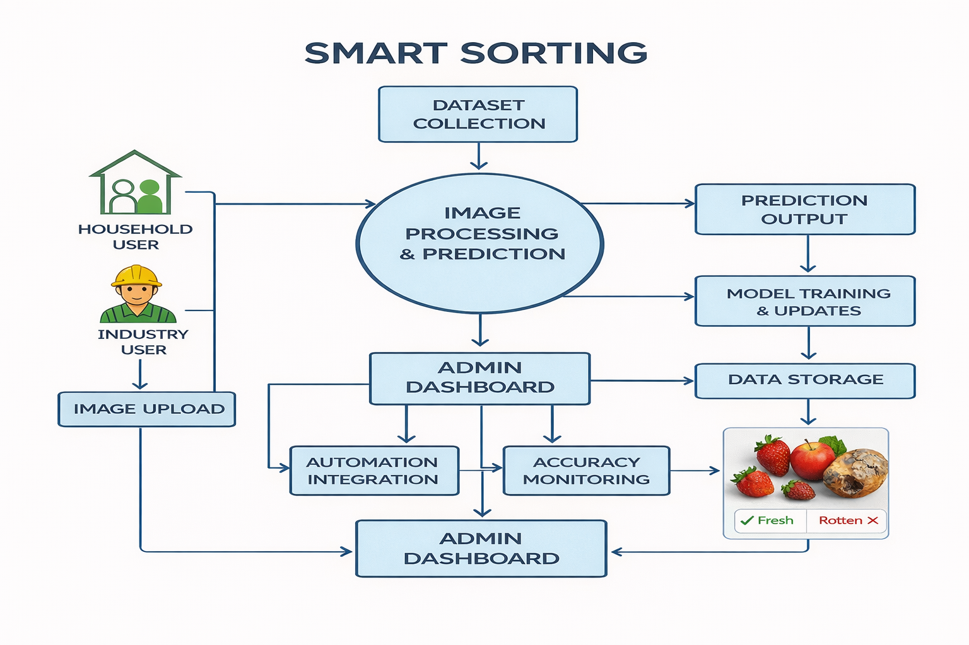
User Stories

User Story Table – DocSpot
User Type | Functional Requirement (Epic) | User Story / Task | Acceptance Criteria | Priority | Release
User | Image Upload | As a user, I can upload an image of a fruit or vegetable. | Image is uploaded successfully and displayed. | High | Sprint-1
 |  | Functional Requirement (Epic): Image Processing | Image is resized and processed correctly. | Medium | Sprint-2
System | Model Prediction | As a system, I can classify the image as fresh or rotten using transfer learning. | Prediction result is accurate and displayed. | High | Sprint-1
User | View Prediction Result | As a user, I can view whether the fruit or vegetable is fresh or rotten. | Result is clearly visible on screen. | Medium | Sprint-2
Developer | Model Training | As a developer, I can train the model using a dataset of fresh and rotten images. | Model achieves acceptable accuracy. | High | Sprint-2
Developer | System Testing | As a developer, I can test the system using different images. | System provides correct predictions. | High | Sprint-2
user | System Usability | As a user, I can easily use the system without technical knowledge. | Interface is simple and easy to use. | Medium | Sprint-2

